Alunos: Nicollas Barbosa Cavalli e Tiago de Oliveira Miguel

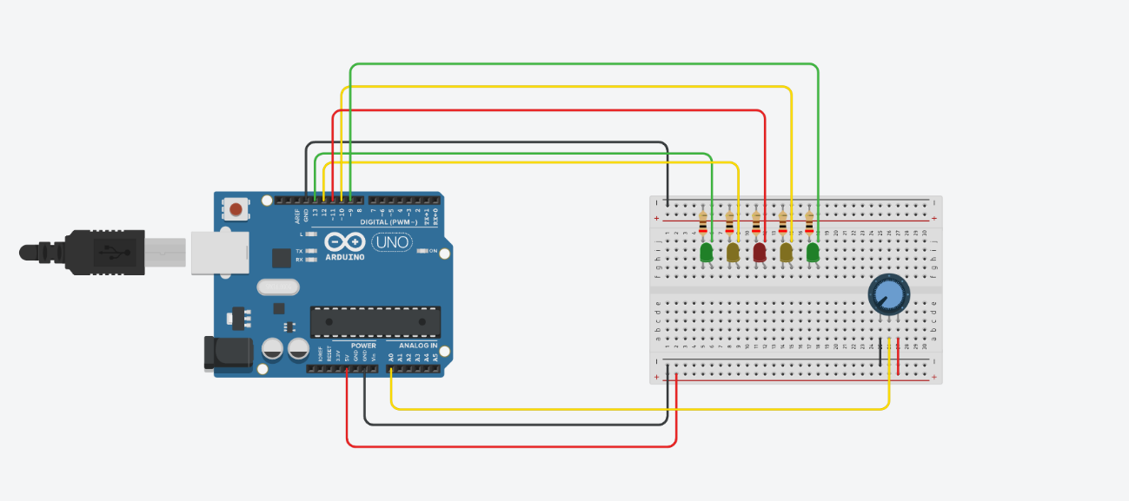
int valor = 0;
void setup()
{
pinMode(A0, INPUT);
pinMode(13, OUTPUT);
pinMode(12, OUTPUT);
pinMode(11, OUTPUT);
pinMode(10, OUTPUT);
pinMode(9, OUTPUT);
}
void loop()
{
valor = analogRead(A0);
if (valor < 180)
{
digitalWrite(13, LOW);
digitalWrite(12, LOW);
digitalWrite(11, LOW);
digitalWrite(10, LOW);
digitalWrite(9, LOW);
}
else if (valor < 360)
{
digitalWrite(13, HIGH);
digitalWrite(12, LOW);
digitalWrite(11, LOW);
digitalWrite(10, LOW);
digitalWrite(9, LOW);
}
else if (valor < 540)
{
digitalWrite(13, HIGH);
digitalWrite(12, HIGH);
digitalWrite(11, LOW);
digitalWrite(10, LOW);
digitalWrite(9, LOW);
}
else if (valor < 720)
{
digitalWrite(13, HIGH);
digitalWrite(12, HIGH);
digitalWrite(11, HIGH);
digitalWrite(10, LOW);
digitalWrite(9, LOW);
}
else if (valor < 900)
{
digitalWrite(13, HIGH);
digitalWrite(12, HIGH);
digitalWrite(11, HIGH);
digitalWrite(10, HIGH);
digitalWrite(9, LOW);
}
else if (valor > 900)
{
digitalWrite(13, HIGH);
delay(250);
digitalWrite(13, LOW);
digitalWrite(12, HIGH);
delay(250);
digitalWrite(12, LOW);
digitalWrite(11, HIGH);
delay(250);
digitalWrite(11, LOW);
digitalWrite(10, HIGH);
delay(250);
digitalWrite(10, LOW);
digitalWrite(9, HIGH);
delay(250);
digitalWrite(9, LOW);
}
}

